

Reg No.

Ph.D. COURSEWORK EXAMINATION – SEPT/OCT 2023 SUBJECT: AEROSPACE ENGINEERING

CORE PAPAER
CODE: COREAE

Time: 03 hours Maximum Marks: 50

Instructions:
- Section A Compulsory
- Answer any four from Section B
- Each question carries 10 Marks

SECTION A

Answer the following question: (10 Marks)

- (a) Figure 1 shows variation of propulsive efficiency of three different types of aircraft engines. Sketch the diagram in your answer sheet and write the type of engine for each variation. (5 Marks)
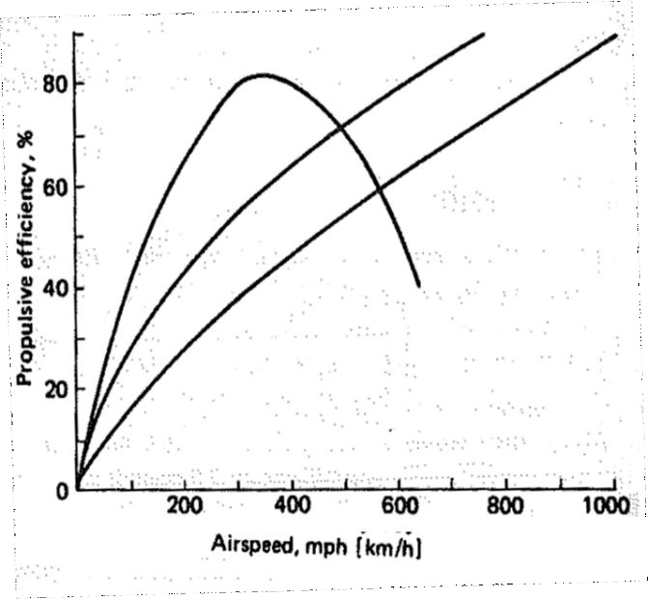
Fig.1. Variation propulsive efficiency with aircraft speed.

  - What are the properties and applications of glass fiber? Explain manufacture of glass fibers with a neat sketch.
(5 Marks)
SECTION B

Answer any four from the following question: (Each carrying 10 Marks)

- (a) Explain the open circuit subsonic wind tunnel with an appropriate sketch. (5 Marks)

  - Explain the flow separation phenomenon over an aerofoil. What is the necessary condition for the flow to be separated? (5 Marks)

- (a) Explain the necessary conditions to achieve complete similarity between the model and prototype. How do you measure freestream velocity inside a subsonic wind tunnel using a Pitot Static tube? (5 Marks)

  - Draw a neat schematic diagram of a high-bypass ratio turbofan engine and label the parts. Identify the components exposed to hot gases. (5 Marks)

- (a) Mention five important performance parameters of an aircraft gas turbine engine and write one or two sentences on each. (5 Marks)
  - A turbofan engine on a test stand in the laboratory operates continuously at a thrust level of 270,000N, with a thrust specific fuel consumption of 0.05kg/h/N. The fuel reservoir feeding the engine holds 3040kg of jet fuel. If the reservoir is full at the beginning of the test, how long can the engine run before the fuel reservoir is empty? (5 Marks)

- Derive the total torque equation with the help of neat sketches for the ‘I’ section beam subjected to torsion.
(10 Marks)

- Derive (σ ) = [ (M I

– M I

2
) / (I I – I

)] x + [ (M I

– M I

) / (I

2
I – I

)] y. (10 Marks)

z y xx
- xy
xx yy xy
x yy
- xy
xx yy xy

- With respect to the avionics in modern aircraft write a description of the following, providing illustrations and graphs as required:
- High-level Avionics Architecture (5 Marks)
- Comparison of Federated Avionics Architecture versus Integrated Modular Architecture (5 Marks)

********

